Coding “Data Diri”

//judul

#include<iostream>

using namespace std;

//kamus

//diskripsi

main()

{

cout << "<=================================>"<< endl;

cout << " Perkenalan Diri" << endl;

cout << "<=================================>"<< endl;

cout << "Nama : Bima Afkanur Rifqi" << endl;

cout << "NIM : A11.2022.14719" << endl;

cout << "Jenis Kelamin : Laki-laki" << endl;

cout << "Domisili : Kab.Semarang" << endl;

cout << "Tinggi : 165 CM" << endl;

cout << "Berat : 56 KG" << endl;

cout << "Angkatan : 2022" << endl;

cout << "Lulusan : 2021" << endl;

cout << "Hobi : Sesuai Minat" << endl;

cout << "<=================================>"<< endl;

}

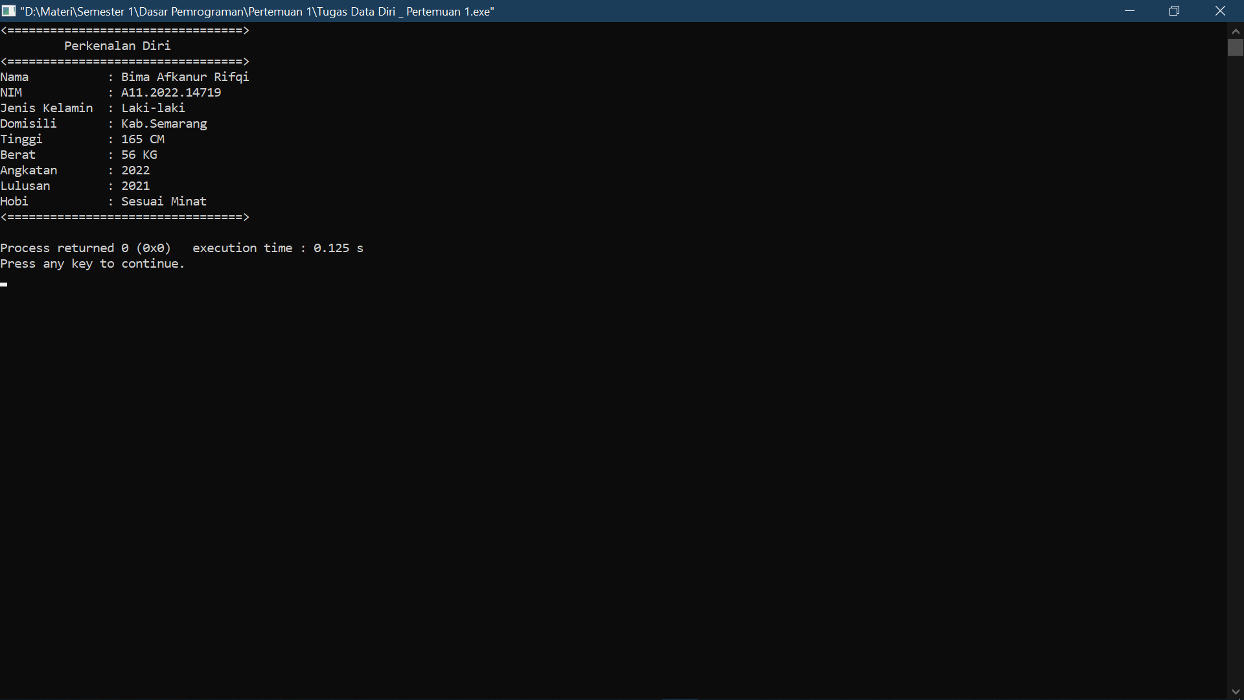

Notasi Algoritma Data Diri

//judul

// Data Diri

// Kamus

// -

// Diskripsi

Output “ Perkenalan Diri ”

Output “ Nama : Bima Afkanur Rifqi ”

Output “NIM : A11.2022.14719 ”

Output “Jenis Kelamin : Laki-laki ”

Output “Domisili : Kab.Semarang ”

Output “ Tinggi : 165 cm ”

Output “Berat : 56 Kg ”

Output “ Angkatan : 2022 ”

Output “Lulusan : 2021 ”

Output “ Hobi : Sesuai Minat ”